Student’s name | …………………………………………………….…… | Grade | 6
Subject | Computer | Week No. | 2
Lesson Title | Poster | Unit
Worksheet No. ( 2 ) (Answer)

Question A: Instruction: Identify the meaning of the following signs

- 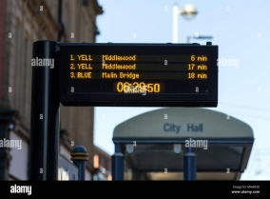 2. 

_____________________________ _____________________

3.  4. 
________________________ ______________________

5. 
________________________
Good Luck

